**RC Garnett Demonstration Elementary School**

Minutes of the General PAC Meeting

Monday, June 15, 2020 6:30 PM

Attendees – Executive

Christos Gitersos, President

Akane Awazu-Ayres, Treasurer

Ivy Rayson, Secretary

Carolyn Brunac, MAL

Elizabeth Castillo, MAL

Reeta Shandil, DPAC 6:38 pm

Julia Ng, Former PAC President

Bruna Grigoletto, MAL, Munch a Lunch

Attendees – Administration

Zoltan Bako, Principal

Attendees – General

Sherona Bussiere

Chad Ludbrook

Raquel Penny 6:38 pm

# Welcome – Christos Gitersos

Christos Gitersos called the meeting to order at 6:32 PM and welcomed everyone.

# Review and Passing of the Agenda dated June 15, 2020.

**Motion**

Christos Gitersos made a motion to accept the agenda dated June 15, 2020. It was moved by Akane Awazu-Ayres. Motion carried.

# Review and Passing of the Minutes from the PAC Meeting from February 10 and April 8

The minutes of the February 10, 2010 General PAC Meeting were reviewed.

**Motion**

Christos Gitersos made a motion to accept the minutes of the February 10, 2020 Meeting. It was moved by Akane Awazu-Ayres. Motion carried.

The minutes of the April 8, 2020 ZOOM PAC Meeting were reviewed.

**Motion**

Christos Gitersos made a motion to accept the minutes of the April 8, 2020 ZOOM PAC Meeting. It was moved by Akane Awazu-Ayres. Motion carried.

# Principal’s Report – Zoltan Bako

* Enrollment up to 565, continuing to grow
* September K registration 5 divisions, 92 kids possibly more
* Staffing
  + Grade 1/2 filled
  + K Filled
  + Burns to be posted
  + Extra division for grade 3/4 to be posted
  + Learning Commons to be posted
* Reporting - Typical for Term 3
  + **CSL** - Communicating Student Learning (Reporting)
  + We're a go for next year Fall and Spring - Calendar Amendments
  + Parent/Teacher Day for Student inclusive interviews as scheduled
* Re-start Plan
  + So nice to have the kids in the building
  + Finish next Tuesday with ESW Thursday
* September
  + We hope to expand on current model
  + Staggered start possible
  + Wait and see for further instructions
* Grade 5s leaving
  + Teachers have something planned to acknowledge grade 5s leaving the school

# Treasurer’s Report – Akane Awazu-Ayres

The Profit and Loss statements for the months ending February 2020 for the General and Gaming accounts were presented.

General Account Activities for February:

* INCOME
  + Hot Lunch $24.00
* EXPENSES
  + Hot Lunch $2957.22 (milk, A&W, Kernels, side items, Pizza Hut)
  + Book Swap $22.92
  + Lunch Without $19.98
* Bank charges $4.95 in and $4.95 out
* Balance of $91,386.53 at February 29, 2020

Gaming Account Activities for February:

* EXPENSES
  + Field Trips $440.00
  + Sports Equipment $1500 (bocce, basketballs, dodgeballs)
  + Music/Art $330.13 (music mallets, tubing etc.)
* Bank charges $1.95 in and $1.95 out
* Balance of $17, 007.61 at February 29, 2020

The Profit and Loss statements for the months ending March for the General and March/April Gaming accounts were presented.

General Account Activities for March:

* INCOME
  + Hot Lunch $19,478.70
* EXPENSES
  + Hot Lunch $873.74 (milk, hotdog buns, wieners, donuts, side items)
* Bank charges $4.95 in and $4.95 out
* Balance of $109,991.49 at March 31, 2020

Gaming Account Activities for March/April:

* EXPENSES
* Bank charges $1.95 in and $1.95 out
* Balance of $17, 007.61 at April 30, 2020

The Profit and Loss statements for the months ending April/May for the General and May Gaming accounts were presented.

General Account Activities for April/May:

* INCOME
  + Hot Lunch $31.00
* EXPENSES
  + Playground $18,782.81
* Bank charges $4.95 in and $4.95 out
* Staff Appreciation $350 (Admin Day, year-end gift cards for 3 admin staff & 3 custodians)
* Balance of $90,889.68 at May 31, 2020

Gaming Account Activities for May:

* EXPENSES
  + Theatre $1076.79
  + Music/Art $334.95 (art supplies)
* Bank charges $1.95 in and $1.95 out
* Balance of $15,595.87 at May 31, 2020

**Motion**

Akane Awazu-Ayres made a motion to accept the Profit and Loss Statement and Balance Sheet for the General Account for the months **February to May 2020**. It was moved by Elizabeth Castillo . Motion carried.

**Motion**

Akane Awazu-Ayres made a motion to accept the Profit and Loss Statement and Balance Sheet for the Gaming Account for the months **February to May 2020**. It was moved by Elizabeth Castillo. Motion carried.

**BUDGET PROPOSAL for 2020-2021**

Budget for next year presented by Akane.

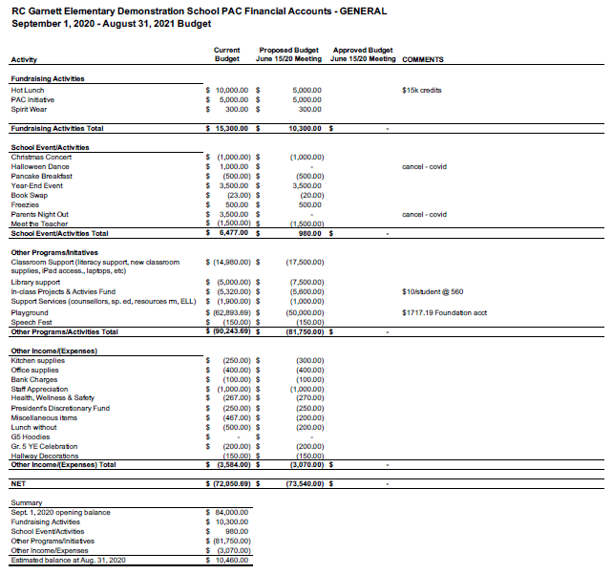

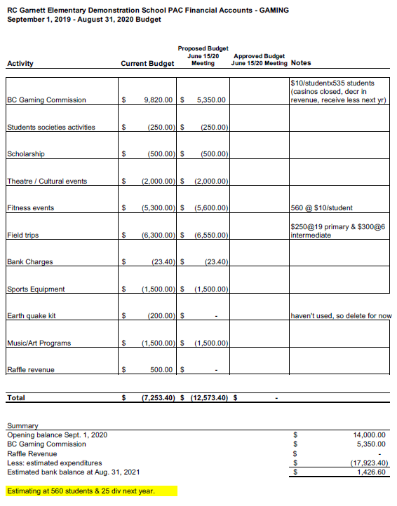

**Motion**

Akane Awazu-Ayres made a motion to accept the 2020-2021 Budget Proposal for the General Account. It was moved by Carolyn Brunac. Motion carried.

**Motion**

Akane Awazu-Ayres made a motion to accept the 2020-2021 Budget Proposal for the Gaming Account. It was moved by Carolyn Brunac. Motion carried.

# DPAC Report – Reeta Shandil

* We are up to date as Gord Stewart's newsletters being shared by Ms. Bradford
* Working on September plans
* $5000 donation to COVID fund
* AGM proceed as decided by each school
* There will be a fee for school bus

# Munch-a-Lunch – Bruna Grigoletto

* Grade 5s refunded for Munch. Others carried forward their balance to next year
* $470 donated
* Munch A Lunch program in limbo due to new COVID regulations. Decision will be made in September
* $26k made in Munch this year! Bravo Bruna!

# General Discussion

* Move money for installed water stations

**Motion**

Akane Awazu-Ayres made a motion to transfer $267 from Health, Wellness line to the Miscellaneous line under the General Account. It was moved by Carolyn Brunac. Motion carried.

**Motion**

Akane Awazu-Ayres made a motion to spend $1000 for Water Stations from Miscellaneous line under the General Account. It was moved by Carolyn Brunac. Motion carried.

* Lunch Without Donations

There are 9 families that are in need of help. We will purchase $50 Superstore gift cards to donate to the families.

**Motion**

Akane Awazu-Ayres made a motion to transfer $40 from Office Supplies line to the Lunch Without line under the General Account. It was moved by Carolyn Brunac. Motion carried.

**Motion**

Akane Awazu-Ayres made a motion to spend $450 for gift cards for families in need from Lunch Without line under the General Account. It was moved by Carolyn Brunac. Motion carried.

* PAC Members Leaving

A thank you gift for all their hard work for the PAC members leaving this year: Jolie Quinton, Jenn Clifford and Julia Ng.

**Motion**

Akane Awazu-Ayres made a motion to spend $160 for gift cards for PAC members leaving from President's Discretion line under the General Account. It was moved by Carolyn Brunac. Motion carried.

* Ms. Sangha is leaving RCG. She will be missed. Good bye gift for Ms. Sangha from PAC.

**Motion**

Akane Awazu-Ayres made a motion to spend $50 for gift cards for Ms. Sangha Staff Appreciation line under the General Account. It was moved by Carolyn Brunac. Motion carried

* ELECTIONS

Julia Ng made a last call for nominations. No further nominations came in therefore nominations were closed. Nominations were as follows:

* + Christos Gitersos, President
  + Carolyn Brunac, VP
  + Elizabeth Castillo, Treasurer
  + Ivy Rayson, Secretary
  + Sherona Bussiere, MAL
  + Bruna Grigoletto, Munch a Lunch, MAL
  + Reeta Shandil, DPAC

By acclamation as per the constitution since every position was uncontested, the positions were filled as nominated.

# Other business

# Upcoming Meeting Dates

The next PAC General Meeting will be scheduled for September 2020.

# Adjournment

There being no further business, the meeting was adjourned at 7:52 PM.