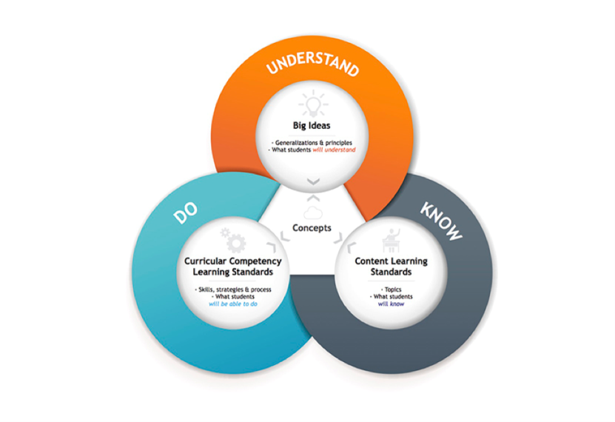B.C. New Curriculum

**Why Change?**

We live in a rapidly changing world that is vastly different than previous generations. In order to ensure our children are well prepared for this deeply connected knowledge-based world they are entering, the Ministry of Education and the British Columbia Teachers' Federation embarked on redesigning our curriculum. The new curriculum will foster the skills and competencies students need to succeed today and in the future. It will be a more flexible curriculum that prescribe less and enables more, for both teachers and stude3nts and a system focused on the core competencies, skills and knowledge that students need to succeed in the 21st century.

**What remains the same?**

* A high quality education system
* The theoretical underpinning of the redesigned curriculum is constructivism or mean-making
* Rigorous Learning Standards
* A strong focus on reading, writing, and mathematics
* Subjects such as Math, Science, Language Arts, and Social Studies remain at the heart of every student’s education
* Valuing applied learning
* Development of educated active citizens
* Provincial assessments will continue to be developed by BC educators

**What is New?**

* An emphasis on depth rather than breadth of study
* More flexibility for teachers to be responsive to student’s needs and passion
* Increased flexibility for teacher innovation
* Clear focus on the skills needed to be successful in the 21st Century: Communication, Creative Thinking, Critical Thinking, Positive Personal and Social Identity, Personal Awareness and Responsibility, and Social Responsibility
* Aboriginal perspectives and content authentically woven into all subjects
* A common framework for all areas of learning
* Honouring experiential learning beyond the classroom
* Opportunity for curriculum subjects to be linked and connected
* Curriculum organized around “Big Ideas”

Curriculum Redesign: Frequently Asked Questions:

<https://curriculum.gov.bc.ca/sites/curriculum.gov.bc.ca/files/pdf/faq.pdf>

BC Ministry of Education: BC’s New Curriculum/Building Student Success:

<https://curriculum.gov.bc.ca/>

SD 35 for Students and parents about BC New Curriculum:

<https://www.sd35.bc.ca/students-parents/bcs-curriculum-redesign/>

BC Ministry of Education Powerpoint:

<http://www.deltasd.bc.ca/files/4070__Ministry_PPT_-_New_Curriculum.ppt>

