**Donna Gabriel Robins Elementary**

**Newsletter #2 September 27, 2024**

7844 204B Street

Langley, BC V2Y 3N9

Phone: 778-726-5555 / Fax: 778-705-9019

<https://dgre.sd35.bc.ca>

**Principal:** Mr. Nathan Erker

**Vice Principal:** Ms. Dunja McCrae

**Administrative** **Assistant:** Mrs. Teresa Tanner

### Upcoming Events

**October 29 – Willoughby Slope Boundary Change Proposal Information Session (6:30pm DGR Gym)**

**October 31 – Happy Halloween**

**November 1 – Hot Lunch**

**November 7 – Remembrance Day Assembly**

**November 8 – Design and Assessment Day (Students Not In Session)**

**November 11 – Remembrance Day (School Closed)**

**November 22 – Hot Lunch**

**November 27 – Student Inclusive Conferences (Students Not In Session)**

**November 28 – Student Inclusive Conferences (2 Hour Early Dismissal – School Ends at 12:30)**

**November 29 – Indigenous Program Winter Solstice Family Gathering (Langley Secondary School)**

**November 29 - Hat Day (put on your favourite hat) and Popcorn Day**

**December 3-5 – Scholastic Book Fair**

**December 12 – Primary (K-2) Winter Concert**

**Umbrella Time:**

The rain has started; however, we will do our best to send students outside for some play time. Please send along a change of clothes. In addition, send your child with a jacket, boots, umbrella or any other items to ensure they are as comfortable as possible while playing outside during the fall. Daily movement and fresh air are important elements in a student’s ability to self-regulate. As such, we will try to go outside at recess and lunch, as much as possible.

**78B Temporary Gravel Road:**

**Do not park along or attempt to make U-Turns on the temporary gravel through road on 78B**. This road was put in place to ensure that we can have a smooth exit from our school grounds. By parking along this road and making U-Turns in front of oncoming traffic is not only unsafe, but it creates delays for the rest of our school community.

**Emergency Response and Procedures:**

Health and safety are a priority in the Langley School District. Schools follow emergency procedures to ensure students, staff, and any visitors in our schools or sites are safe when unexpected incidents or events happen. At the start of every school year, administrators, teachers, and staff review these emergency procedures. Schools practice a set number of drills annually in preparation for unexpected situations. The district encourages families to become familiar with these staff emergency procedures and the drills that are completed in schools. You can read them in the Staff Emergency Procedures Poster [**here**](https://www.sd35.bc.ca/wp-content/uploads/sites/2/2023/10/Staff-Emergency-Procedures-Poster.pdf) or find them posted in areas throughout District buildings. If you have questions or concerns about emergency procedures, please contact your child’s teacher or principal.

**Willoughby Slope Boundary Changes Proposal Info Sessions:**

The district is continuing with the next phase of information sessions, as part of the process to open the N.E. Latimer Elementary school in September 2025. The district is inviting all families in the Willoughby Slope to learn more about the district’s proposed catchment boundary changes impacting elementary schools in the R.E. Mountain family of schools. The district has met with school communities, gathered and reviewed the feedback, and has developed a plan to share with families. Families are welcome to attend any one of the following info sessions to learn more about the proposed changes, ask questions, and provide feedback. See below for dates and times.

|  |  |  |
| --- | --- | --- |
| **Willoughby Elementary**  **October 28**  **6:30 pm**  **Gym** | **Donna Gabriel Robins Elementary**  **October 29**  **6:30 pm**  **Gym** | **Langley Meadows Community School**  **October 30**  **6:30 pm**  **Gym** |

If you have any questions about the info sessions, please contact the school. If you have questions about the boundary changes process and proposal, please email: [feedback@sd35.bc.ca](mailto:feedback@sd35.bc.ca)

**Remembrance Day Message from our District:**

It is a long-standing tradition for schools to support our veterans and the efforts of the [Royal Canadian Legion](https://legion.ca/home). Once again this year, our school will be receiving a poppy for every student and distributing them to classes. We will continue to collect funds this year in support of the Legion’s Poppy Campaign but kindly ask students and their families to donate online via School Cash Online: <https://sd35.schoolcashonline.com/>. Please do not send cash or cheques with your child to school.

We appreciate your generosity. As always, our school is committed to educating our community about the meaning of the poppy and Remembrance Day.

**Student Inclusive Conferences:**

This year our Student Inclusive Conferences will take place on **November 27 & 28**. However, many staff may create a schedule that includes several other dates. Scheduling will take place on School Appointments Online. Information about the conferences and directions of how to log into School Appointments Online will be sent November 8. If you are interested in the Student Inclusive Conference Process or the rationale for the move away from the traditional Parent/Teacher Interview, please click this link [Student Inclusive Conferences](https://langleyschoolsca.sharepoint.com/:b:/s/InstructionalServices/ESj9zj3-7A5Om7NJQkerDrsBjvJVRmxpJuTrS2Hu_zN11w?e=BOqR6t)

**Happening Around DGRE:**

**Grade 5 Hoodies are On-Sale Now**

We are now taking orders for Grade 5 hoodies. **All orders must be made** on [School Cash Online](https://www.schoolcashonline.com/)

The hoodie will have a “Class of 2025” logo on the back filled with their signatures and the school’s owl logo on the front left chest. The price per hoodie will be $34 (taxes and shipping included). A sizing chart can be found below. If you choose to place an order, please be sure to have your **order in by November 12, 2024**.

**DGR Spirit Wear:**

Owls now is your chance to order some DGR gear. If you are interested in ordering, please **go directly to the website by clicking this** [**link**](https://www.9blocks.ca/dgrspiritwear)**.**

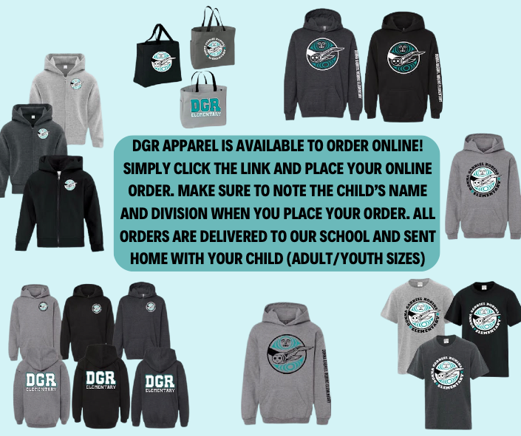

**Boo!! – It’s Pumpkin Time:**

With Halloween around the corner, we wanted to remind our community about our school expectations. We would love to see our students dress up on Thursday, however, we do ask that students **refrain from wearing masks or bringing any sort of toy weapon.** As well, please consider not sending additional props for your child’s costume, just in case they break or get lost. We want them to be in their full Halloween Gear when then are out there safely Trick or Treating.

**Noon Hour Supervisor Needed:**

DGR is looking to add an additional Noon Hour Supervisor to our staff. We have attempted to post this position but had no luck with applicants. As such, we need to reach out to our community. DGR’s lunch hour runs from **12:00 – 1:05pm**. The rate of pay is $27.16 per hour for noon supervisors.

Applicants need to provide the following:

1. Complete and signed application form (attached)
2. Current resumé
3. High school diploma or transcript to confirm completion of at least Grade 10
4. Valid first aid certificate

If you are interested in supporting our school and applying for this position please click on the [job description](http://dgre.public.sd35.bc.ca/wp-content/uploads/sites/97/2024/10/Noon-supervisor-JD.pdf) as well as the [external application form](http://dgre.public.sd35.bc.ca/wp-content/uploads/sites/97/2024/10/External-App-Support-2015-2.pdf).

Once the application form is completed, please bring it into the office, along with the other required paperwork, and we will submit your application to our Human Resources Dept.

**Donna Gabriel Robins Elementary**

**General PAC Meeting Agenda**

**Tuesday, November 05, 2024**

**6:30 pm School Gym**

**Call to Order**

**Welcome**

**Land Acknowledgement**

We respectfully acknowledge that we work and learn on the traditional, ancestral and unceded territories of the Matsqui, Kwantlen, Katzie and Semiahmoo First Nations.

**Introductions**

**Principal’s Report**

**Treasurer’s Report**

-Present and pass October 2024 General Account Financials

-Present and pass October 2024 Gaming Account Financials

**Secretary’s Report**

-Present and pass October 2024 minutes

**DPAC Report**

**Old Business**

* Halloween Dance Profit
* Halloween Dance Feedback
* Spirit Wear live Oct 21
* Charlie’s Chocolate Factory live Nov 01
* Giants Fundraiser
* Update on Vancouver Warrior’s
* Update on Pancake Breakfast

**New Business**

* + Compassionate fund donations to families in need. Possibly collecting items in need November to donate directly to families
  + Update donations made on munch
  + Christmas tree colouring contest

**Open Discussion**

**Next PAC Meeting**

**Adjournment**